**Curve Analysis with 1D Haar Wavelets**

To apply 1D HWT to images for detecting flats, climbs, and declines of a bee landing pad. My algorithm consists of 2 steps:

1. 1D HWT
2. Curve Detection

Using these steps, I could detect the bee landing pad and draw boundaries in all the images.

**1D HWT** - To detect boundary of the landing pad, I iterated through each column and row of the image transformed to the nearest power of 2 and ran it through 4 iterations of inPlaceFastHWT. I applied this in the form of edgeDetection row and column, to determine horizontal, vertical and curves. The below screenshot shows the output of grass image after 1D HWT

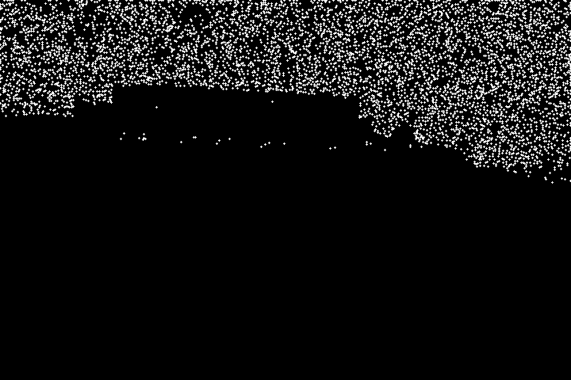

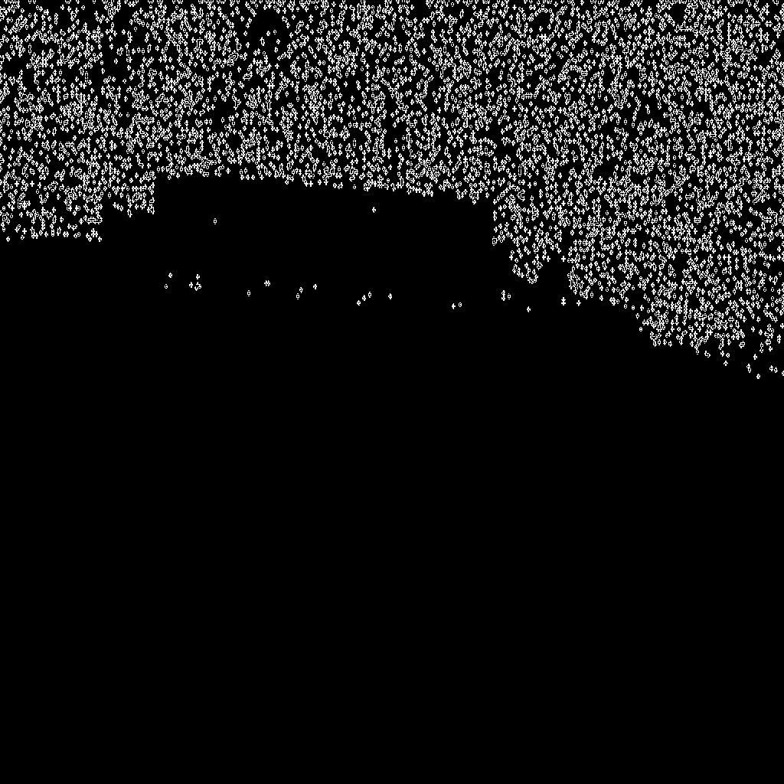

**Curve Detection** - To identify the flats, climbs and decline, I read the HWT image and added a threshold of pixel value >200. I calculated the sum of white pixels in each column and then to made a set of 5 consecutive columns as one to find the variation in white pixels. Whenever a change will be observed we create a histogram bar which provides the boundaries of the pad. These are used to draw boundary. The histograms used were not as expected. But this could be the easiest way to find boundaries and detect the pad.

In observing the shape of the landing pad, I noticed that they all seem to be slightly skewed and not perfectly rectangular. My algorithm remains true to this observation and detect all four corners individually, leading to true detections without requiring perfect rectangularity.